21 July 2015
Team Mercia Polo Shirt

We are building an order for poolside shirts which will be placed with the supplier in August, please submit your order to the relevant contact in your home club along with payment before you go on holiday, orders will close on the 7th August, clubs collated orders and payment must be in with Team Mercia no later than the 14th.

Leamington – Shaun O’Brien
Nuneaton – Sue Newman
Stratford – Joy Beamer

This will be the last order before the Midland & National SC Championships this Winter so please make sure you get your order in now. Indicate clearly the Size, Qty and any ‘NAME’ for the rear of the shirt in Block Capitals please.

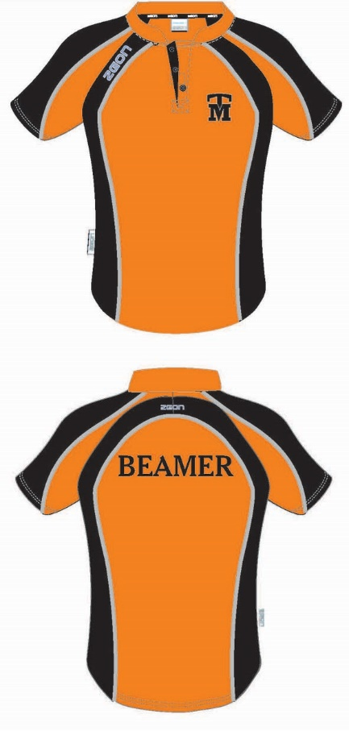
Ordered by:
Size
Qty
Rear Name
Total Cost

 |  | Child | Adult
Polo Shirt | Zeon Performance Poolside Shirt | £ 18.50 | £ 22.00
 | Name | £ 2.50 | £ 2.50
Plain Black Shorts |  | Own source
Hat |  | £6.00

The hats are already stocked at each of Leamington, Stratford and Nuneaton.

Child Sizes | 9-10 yrs | 11-12 yrs | 13 yrs
Chest (in) | 28 | 30 | 32

Adult Sizes | 2XS | XS | S | M | L | XL | 2XL | 3XL | 4XL
Chest (in) | 34 | 36 | 38 | 40 | 42 | 44 | 46 | 48 | 50

